Ex. No. : 01B Date: 22.01.2026
Register No.: 231701046 Name: Sam Sundar

Check In & Check Out
Aim:
Develop an application for Tech Lounge Check in / Check out App. to count number of students inside the block.

Procedure:
- Create a New Android Project
- Open Android Studio.
- Select New Project → Empty Activity.
- Enter the application name as Experiment2_MADD_46.
- Choose Kotlin as the programming language.
- Click Finish.
- Configure AndroidManifest.xml
- Open AndroidManifest.xml.
- Declare MainActivity.
- Add the MAIN action and LAUNCHER category so that the app starts from MainActivity.
- Set the application theme.
- Design the User Interface
- Open activity_main.xml.
- Use a LinearLayout with vertical orientation.
- Set gravity to center and add padding.
- Add a TextView to display the counter value.
- Add two Buttons:
  - Check In (Increment)
  - Check Out (Decrement)
- Assign proper IDs to all UI components.
- Write the Kotlin Code
- Open MainActivity.kt.
- Call setContentView() to load the layout.
- Declare an integer variable counter and initialize it to 0.
- Access UI components using findViewById().
- Implement setOnClickListener():
  - Check In button increments the counter value.
  - Check Out button decrements the counter value.
- Update the TextView with the current counter value.
- Run the Application
- Connect an emulator or Android device.
- Click Run ▶ in Android Studio.
- Launch the application.
- Verify the Output
- Clicking Check In increases the counter value.
- Clicking Check Out decreases the counter value.
- The updated value is displayed dynamically on the screen.

AndroidManifest.xml

<?xml version="1.0" encoding="utf-8"?>
<manifest xmlns:android="http://schemas.android.com/apk/res/android"
xmlns:tools="http://schemas.android.com/tools">
<application
android:allowBackup="true"
android:dataExtractionRules="@xml/data_extraction_rules"
android:fullBackupContent="@xml/backup_rules"
android:icon="@mipmap/ic_launcher"
android:label="@string/app_name"
android:roundIcon="@mipmap/ic_launcher_round"
android:supportsRtl="true"
android:theme="@style/Theme.Experiment2_MADD_46">
<activity
android:name=".MainActivity"
android:exported="true">
<intent-filter>
<action android:name="android.intent.action.MAIN" />
<category android:name="android.intent.category.LAUNCHER" />
</intent-filter>
</activity>
</application>
</manifest>

Activity_main.xml

<?xml version="1.0" encoding="utf-8"?>
<LinearLayout xmlns:android="http://schemas.android.com/apk/res/android"
android:layout_width="match_parent"
android:layout_height="match_parent"
android:orientation="vertical"
android:gravity="center"
android:padding="24dp">
<TextView
android:id="@+id/tvCounter"
android:layout_width="wrap_content"
android:layout_height="wrap_content"
android:text="0"
android:textSize="48sp"
android:layout_marginBottom="32dp" />
<Button
android:id="@+id/btnIncrement"
android:layout_width="175dp"
android:layout_height="wrap_content"
android:text="Check In" />
<Button
android:id="@+id/btnDecrement"
android:layout_width="174dp"
android:layout_height="wrap_content"
android:layout_marginTop="16dp"
android:text="Check Out" />
</LinearLayout>

MainActivity.kt

package com.example.experiment_2_madd_46
import android.os.Bundle
import android.widget.Button
import android.widget.TextView
import androidx.activity.enableEdgeToEdge
import androidx.appcompat.app.AppCompatActivity
class MainActivity : AppCompatActivity() {
override fun onCreate(savedInstanceState: Bundle?) {
super.onCreate(savedInstanceState)
enableEdgeToEdge()
setContentView(R.layout.activity_main)
var counter = 0
val tvCounter = findViewById<TextView>(R.id.tvCounter)
val btnIncrement = findViewById<Button>(R.id.btnIncrement)
val btnDecrement = findViewById<Button>(R.id.btnDecrement)
btnIncrement.setOnClickListener {
counter++
tvCounter.text = counter.toString()
}
btnDecrement.setOnClickListener {
counter--
tvCounter.text = counter.toString()
}
}
}

Output:

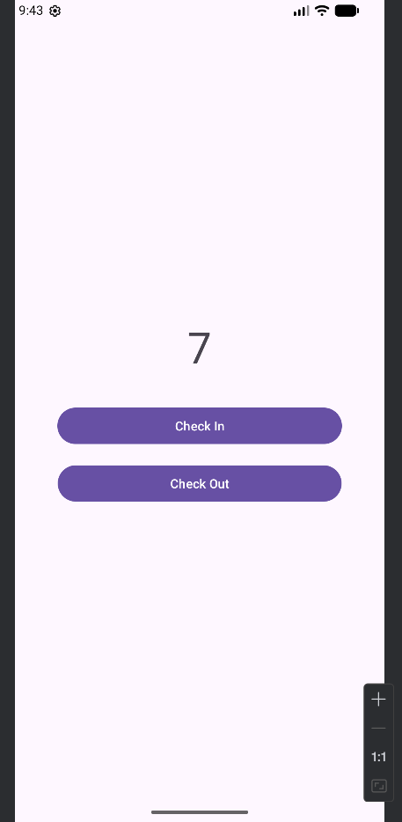

Result:
The Android application was successfully developed to implement a counter system using buttons for increment (Check In) and decrement (Check Out) operations.

